Name: Vishnu Mohan
Roll No: 51
Batch: MCA B
Date: 02-06-2022

NETWORKING & SYSTEM ADMINISTRATION LAB

Experiment No.: 24

Aim
To familiarize with the installation of wireshark
Procedure
1. Open the terminal on Ubuntu
2. Install Wireshark
$ sudo apt-get install wireshark
Output:-
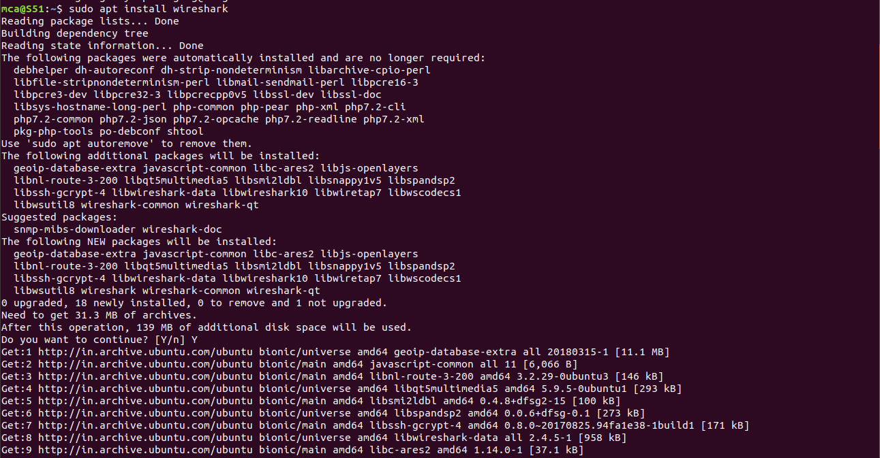

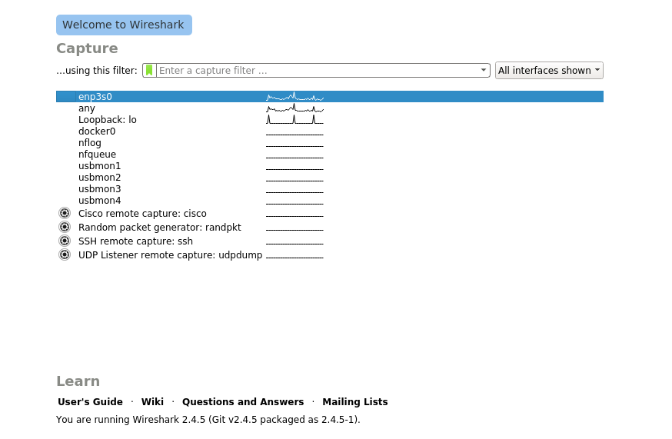
3. add the user mca to the wireshark:
$ sudo user add mca

Output:-
4. $ sudo wireshark
This will open a wireshark interface on the system through which we can see packet information
$ sudo wireshark
Output:-

